Audible Frequency Response

ECE 598 Final Project Report - Spring 2024

________________________________________________________

Soham Manjrekar

([sohammm2@illinois.edu](mailto:sohammm2@illinois.edu))

Professor: Dr. Arijit Banerjee

TA(s): Anuj Maheshwari and Matthew Qi

May 10, 2024

**Abstract**

This laboratory experiment explores the audible effects of varying control with boost converters, focusing on open-loop and closed-loop operations. We will demonstrate the frequency spectra of converter operation using our ears since the human brain considers audio in the frequency domain. This study investigates how factors such as duty cycle variations, input voltage changes, and proportional-integral controller parameters influence sound characteristics. Through experimental setups and programmed scenarios, the research aims to reveal the dynamic behavior of boost converters and the impact of control design on their performance which will supplement existing student insight into optimizing converter stability and response.

**Table of Contents**

**1 Objective** **4**

**2 Background** **4**

**3 Implementation** **4**

3.1 Task 1 4

**4 Collected Data / Study Questions** **4**

# 

# 1 Objective

Investigate how different control topologies affect the perceived sound characteristics.

# 2 Background

Throughout the course of this class and previous labs, we’ve learned about transfer functions for open-loop and closed-loop operation of power converters. Many critical elements of these transfer functions occur within the audible range. The human mind interprets sound as a frequency spectrum, higher frequencies evoke a "brighter" pitch or impulse for example, while lower frequencies elicit a "darker" pitch.

For this lab in particular, we will be using a boost converter (full experiment topology shown in **Figure X**), a boost converter is a DC-DC converter (covered in ECE 464) that steps up voltage. We will be employing it to explore the audible effects of the transfer function by varying levels of control stability in both open and closed loop.

In open-loop mode, the duty cycle of the switching signal is set without direct feedback from the output voltage. Without feedback, the converter is switching between two duty cycles to drive an output voltage. This output may experience fluctuations due to changes like variations in load conditions, input voltage, or other external factor. These fluctuations result in audible effects in the operation of the converter. For instance, when switching between duty cycles the output voltage may over or undershoot the expected value, this discrepancy gives us distinct sound characteristics that correspond to the transfer function of the control topology.

In closed-loop mode, where we utilize feedback from the output voltage, the goal is to maintain a stable output regardless of external factors. With a stable controller, you will observe smoother operation and potentially fewer audible artifacts with closed-loop control. However, we will also observe the auditory feedback of an unstable converter.

The transfer function of a boost converter describes the relationship between its input and output voltages. In open-loop operation, this transfer function can be affected by factors such as duty cycle changes and input voltage variations, which disturbs the output voltage leading to audible differences in the converter's operation. In closed-loop operation, the transfer function is influenced by the controller parameters, such as proportional and integral gains (PI values), which affect the stability and response time of the system, also wrestling in audible differences in the converters operation. In this lab you will see the converter operate in open loop mode and closed loop mode at nearly the same operating point, and will be able to hear the difference between the two.

# 3 Control Scheme

The control scheme for this project closely resembles that of previous labs. In open-loop control, there are minimal changes, except for the addition of a frequency sweep mode, which will be addressed later. For control portion of closed-loop control, the implementation mirrors that of a buck converter's control. As illustrated near the end of **Figure 3.1**, this control scheme inverses the integrated part of the PI Control, yielding outcomes akin to a genuine boost controller. This solution is apt for our scenario as our project aims to showcase variances in transfer functions across different operating points. The specific topology and its control are of secondary importance compared to our ability to adjust the level of control stability. A boost converter suits our requirements since it ensures a voltage output suitable for driving a speaker at a specified volume level, facilitating clear differentiation in sound output.

Furthermore, different modes are set up in the same Figure. Mode 1 represents an incredibly unstable controller where Kp and Ki (our control variables) fail to effectively manage the overshoot and undershoot of the output. Mode 2, although an improvement, still operates near the unstable point of the transfer function. In our results section, we will review how the waveforms from Mode 1 and Mode 2 are quite similar. Auditorily, we will observe that they produce the same level of loudness. However, Mode 2 exhibits significantly less sibilance and resonance than Mode 1.

The final modification involves simulating a square wave in closed-loop mode. By activating V_bounce, the desired output voltage of the boost converter changes at a rate defined by count_var, effectively simulating a square wave as our input. We have the flexibility to define the bounds of the square wave. For our experiment, we typically maintained our voltage between 13.5 and 18 to closely match the operation of the open-loop mode, where the duty cycle switches between 0.44 and 0.62.

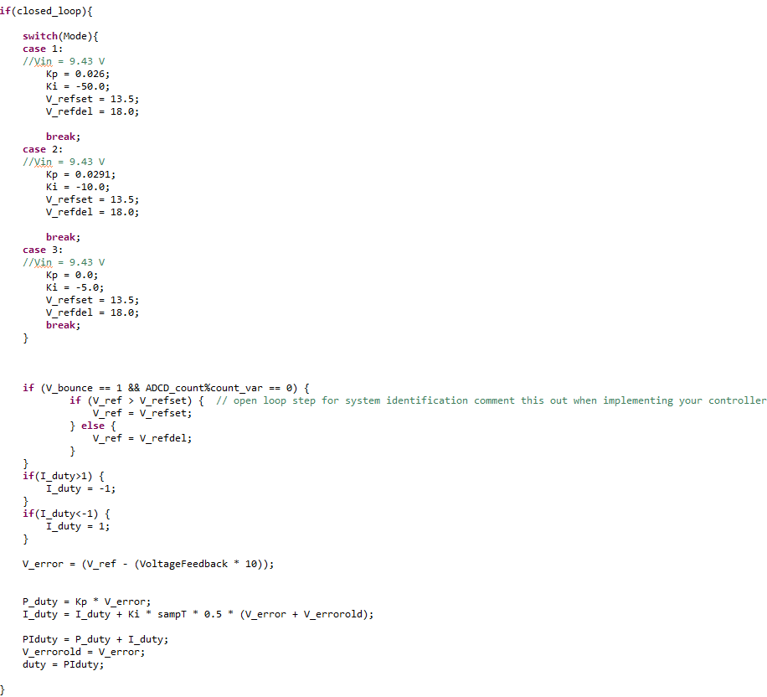

**Figure 3.1:** Closed Loop Control Code

Another noteworthy update to our code from the previous lab is the incorporation of a frequency sweep, applicable in both open and closed-loop modes as depicted in Figure 3.2. This feature alters the rate at which we transition between voltages (in closed loop) or duty cycles (in open loop) by utilizing the ADCD_count variable as a counter. Essentially, when not in sweep mode, the switching frequency remains constant.

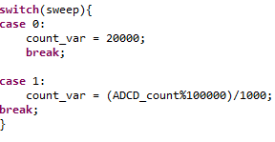

**Figure 3.2:** Frequency Sweep

# 

# 4 Implementation

For this lab, we'll assemble a conventional boost converter employing the ECE 469 boards, paired with a 50 ohm load. Alongside this load, we'll have a speaker connected in series with a 220uF capacitor to filter out DC current. The second output capacitor in the schematic corresponds to Vmid_sense. We'll probe the switching signal, output current, output voltage, and Vmid_sense voltage to monitor their behavior during operation.

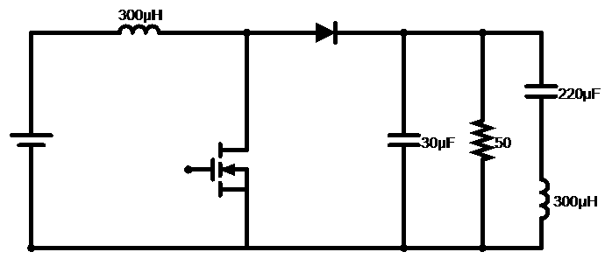

**Figure 4.1**: Experiment Circuit Diagram

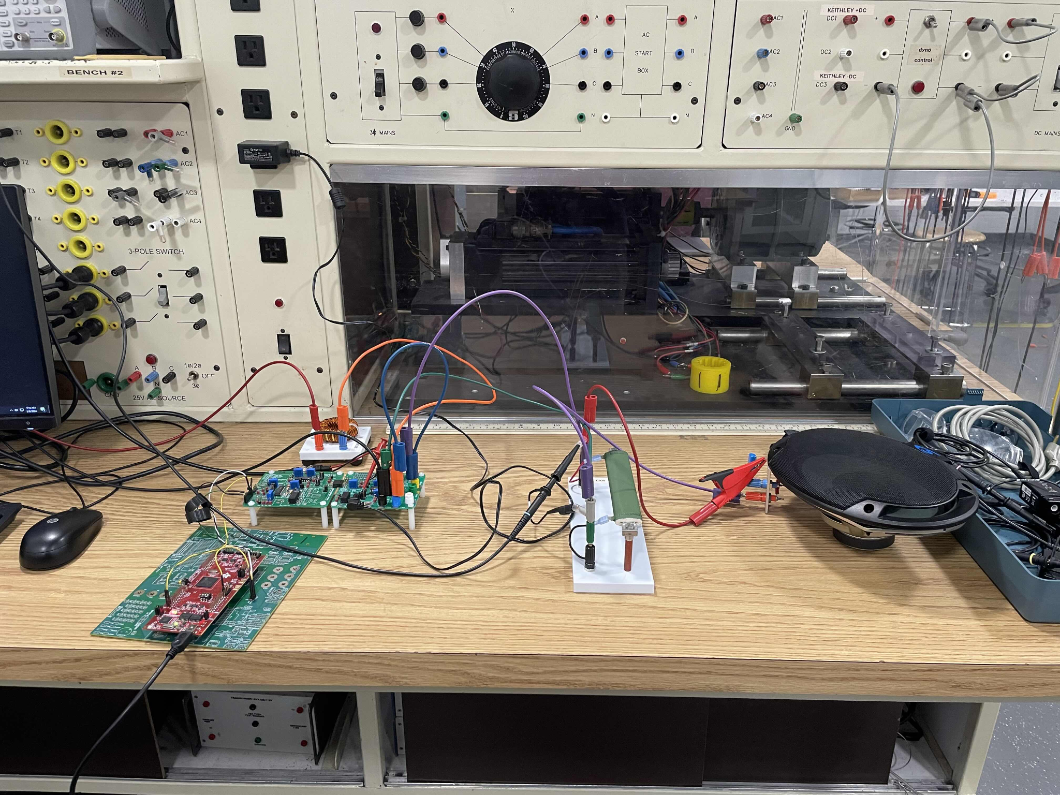

**Figure 4.2:** Circuit Test Setup

## 4.1 Task 1 - Open Loop Transfer Function

To begin the experiment, the controller was initially set to open loop mode to ensure the proper functionality of the boost converter. Once verified, the controller was then programmed to alternate the duty cycle between 20% and 60% every second, maintaining a consistent input voltage of 10 volts. Following this setup, the audio output was observed during both the upswing and downswing of the duty cycle to detect any perceptible differences in sound characteristics. Subsequently, a square wave oscillator was implemented using the sweep function, enabling a sweeping frequency range from 20 Hz to 5 kHz over a duration of 5 or 10 seconds. With the peak and minimum values of the oscillator set to 60% and 20% respectively, the duty cycle of the boost converter was adjusted to match the output of the oscillator. This experimental configuration allowed for the assessment of volume changes in response to varying frequencies, providing insights into the relationship between frequency variations and audio output levels.

## 4.2 Task 2 - Closed Loop Comparison

In transitioning the controller to closed-loop mode, arbitrary proportional-integral (PI) values were selected initially, intentionally rendering the controller unstable. Following this setup, the reference voltage (V_ref) was programmed to alternate between 14 and 18 volts at one-second intervals. Upon activating the voltage input, the speaker output was observed, noting any discernible changes in sound quality. Adjustments to PI constants were made to gauge their impact on the controller's stability and performance. The PI values were iteratively fine-tuned until the controller teetered on the brink of stability during transient states, inducing noticeable resonance that gradually subsided over time. Subsequent variations in the input voltage were introduced incrementally to observe corresponding changes in the decay time of the resonance, shedding light on its sensitivity to input voltage fluctuations. Additionally, the pitch of the resonance was monitored over time to ascertain any fluctuations and potential causes thereof.

# 5 Results

## 5.1 Task 1 - Results

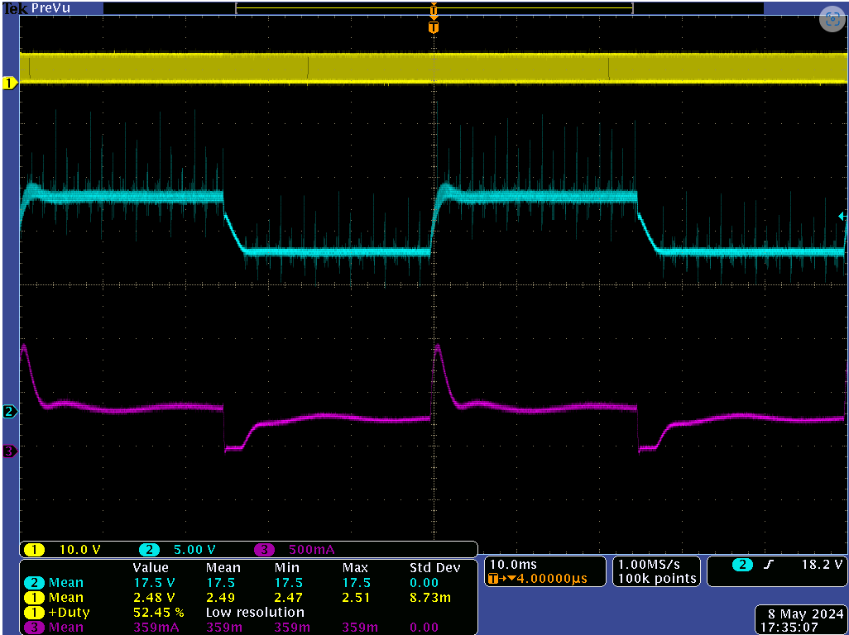

**Figure 5.1:** Open Loop Voltage and Current @ 10V input

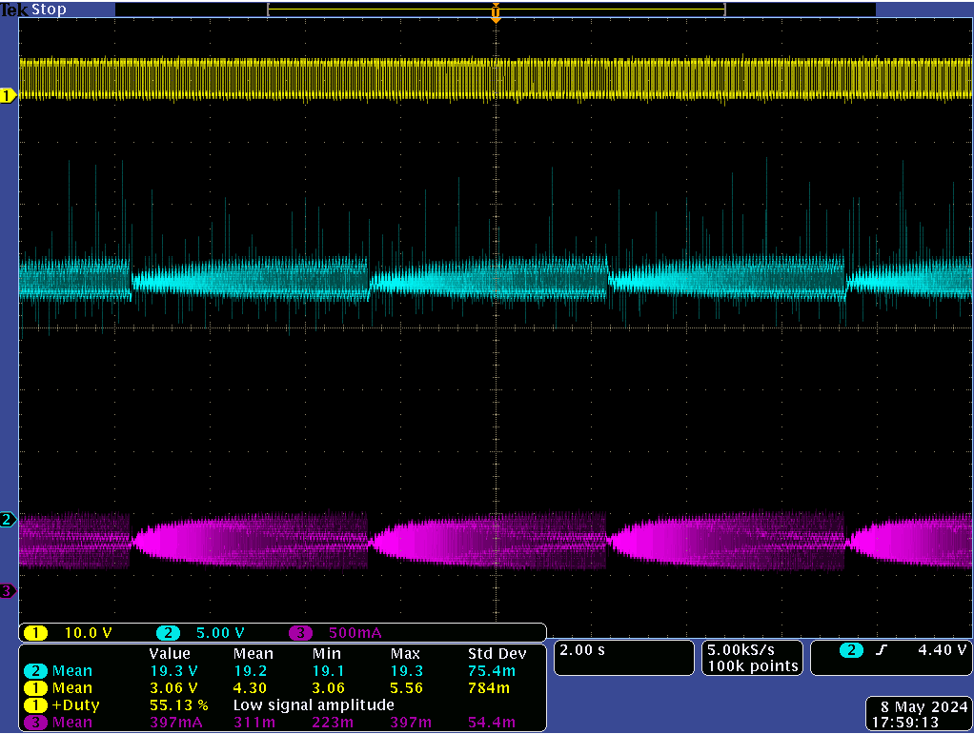

**Figure 5.2:** Open Loop Frequency Sweep @ 10V input

In Figures 5.1 and 5.2, the duty cycle (yellow), output voltage (blue), and load current (pink) are depicted. Notably, in Figure 5.1, a resonance in the waveform is evident during the overshoot phase. During this mode of testing, the sound emitted from the speaker resembled the characteristic bounce of a rubber ball, complete with a distinct impact followed by an echoing reverberation over time. Described metaphorically, it closely resembled the sound of a dodgeball hitting the floor with a distinct "Phoontkk" sound, marked by resonance and sibilance. Meanwhile, the frequency sweep revealed a smooth widening of the waveforms as the frequency increased. Auditorily, this corresponded to a gradual rise in pitch, akin to the smooth increase in frequency (note as well the time scale for the frequency sweep).

## 

## 5.2 Task 2 - Results

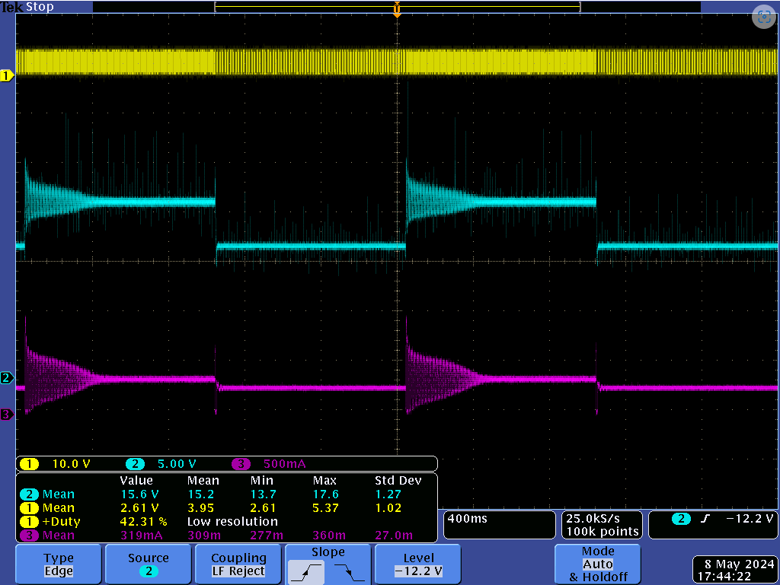

**Figure 5.3:** Closed Loop, Barely Stable Transient

In Figure 5.3, we observe the closed-loop operation in "Mode 0," where the mode is not set, granting the user full control. In this state, we found an operating point where the system was unstable yet eventually settled. The voltage and current waveforms distinctly deviate from those in open-loop configurations. The sound produced under this condition resembled the winding down of a turbine or jet engine, with initial high pitches gradually tapering off to lower ones. Employing onomatopoeia, the sound can be described as "Whirrrrrooowwww."

Transitioning to the actual modes of the controller, we examine the waveforms for Mode 1, 2, and 3 as depicted in Figures 5.4, 5.5, and 5.6, respectively. In Mode 1, we witness an almost uncontrolled transition between the switching voltages of the converter, characterized by significant ringing and an output voltage peaking at nearly double the intended value. The sound emitted from the speaker during this mode resembles a "parp," similar to the sound of an alarm or siren, with noticeable resonance or grain, resulting in an unclear tone. Since this controller is stable, the sound does not persist over time, manifesting as a single impulse (unlike our Mode 0 demonstration).

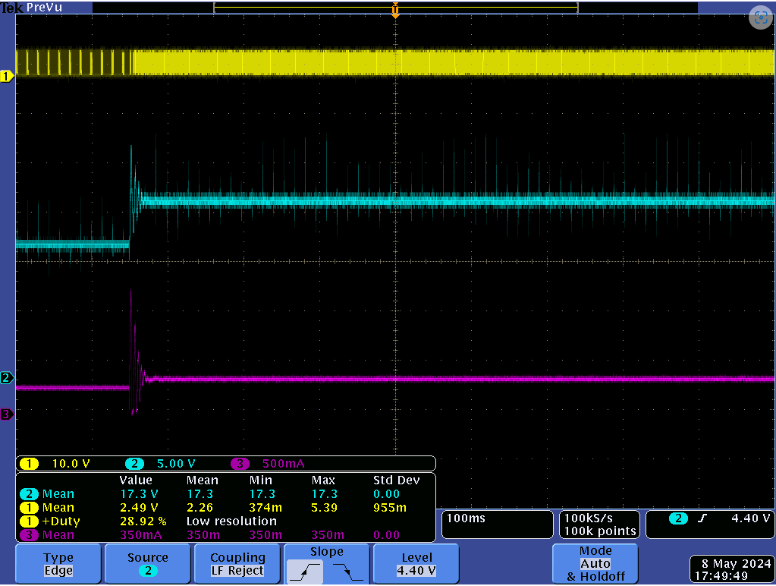

**Figure 5.4:** Mode 1 Overshoot

Moving to Mode 2, we observe a slightly better-controlled transition between voltages, resulting in a cleaner tone with reduced resonance and grain. However, the fundamental pitch and tone of the sound remain unchanged from Mode 1. Additionally, the volume levels of the sounds in both Mode 1 and 2 are nearly identical.

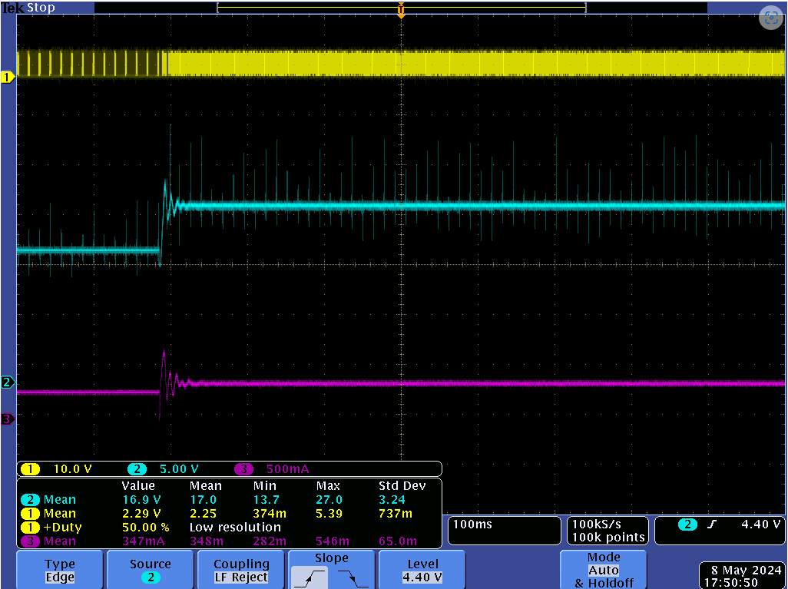

**Figure 5.5:** Mode 2 Overshoot

Finally, in Mode 3, we achieve perfect control with no overshoot or undershoot. The sound experienced at this operating point is nearly silent, with only the faint "bum" sound of the output voltage's square wave, characterized by a very low pitch and minimal resonance.

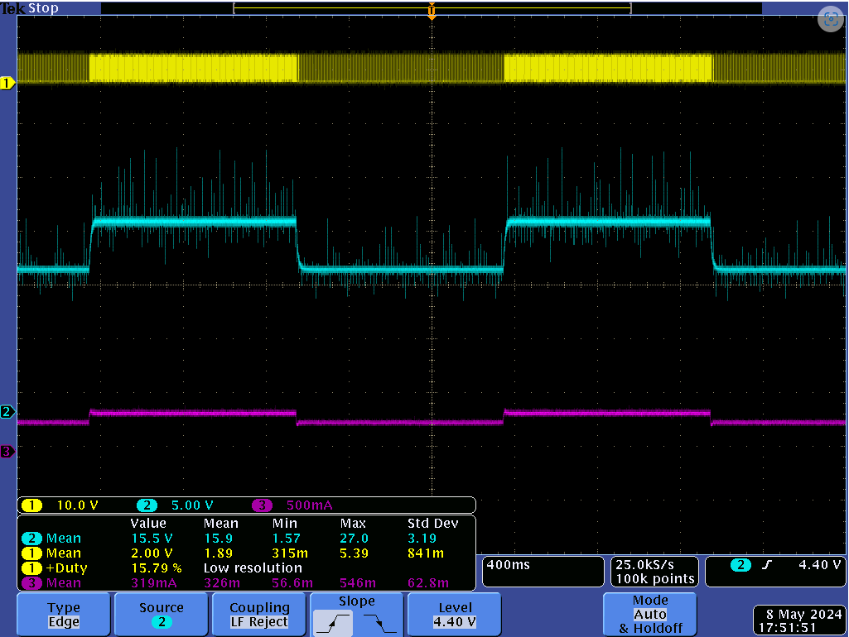

**Figure 5.6:** Mode 3 Overshoot

To end the experiment let us compare the frequency sweep waveforms to that of those done in open loop. We shall compare mode 2, our generally controlled operating condition with mode 3, our perfectly controlled operating point, and of course the open loop. We will ignore modes 0 and 1 since mode 0 is unstable and mode 1 is stable but uncontrolled, using their frequency sweeps will give us very little insight.

Figure 5.7 illustrates how the peak-to-peak amplitude of the output voltage escalates as the frequency of the input square wave rises, showcasing a significant deviation compared to the open-loop configuration. This controller demonstrates poor performance in maintaining an average voltage. Sonically, this segment of the experiment resembled the sound of an ambulance, featuring digital chirps and irregularities interspersed throughout. While the pitch of the sound generally tracked the increasing frequency trend, noticeable gaps and jumps in peak-to-peak voltage corresponded to instances where chirping and digital artifacts were observed in the sound output.

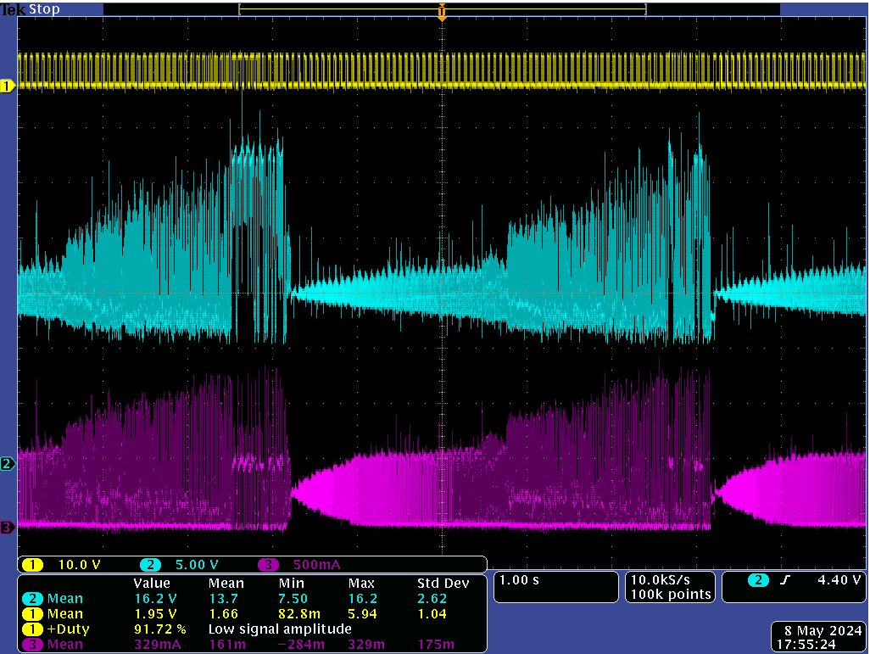

**Figure 5.7:** Mode 2 Sweep

In the Mode 3 sweep detailed in Figure 5.8, disregarding the initial shift in scope position captured in the screenshot, we note that the peak-to-peak voltage remains remarkably close to the anticipated value. Consistent with our observations during regular Mode 3 operation, we detected minimal auditory anomalies or irregularities. As expected, the pitch increased with frequency. The only noticeable sound occurred around the point where the sweep cycle began anew, marked by the reset of peak-to-peak current to its minimum. It is at this point where a slight peak in the output voltage waveform coincided with a brief chirp emitted by the speaker. Otherwise the mode 3 sweep sounded like someone practicing their scales on a piano very quietly.

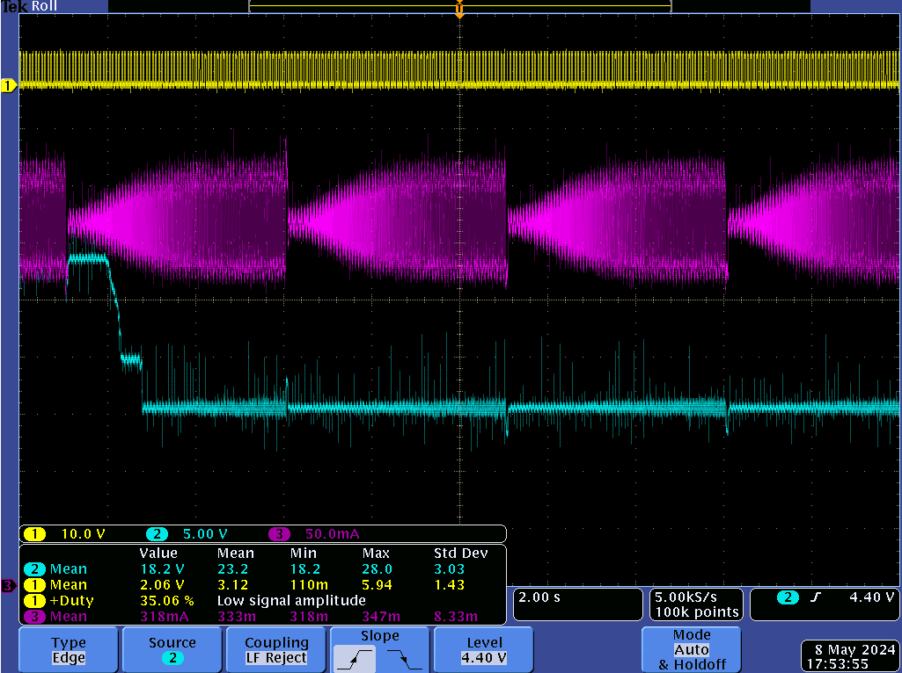

**Figure 5.8**: Mode 3 Sweep

# 

# 6 Conclusion

In conclusion, this laboratory experiment delved into the audible effects of manipulating control parameters in boost converters, emphasizing both open-loop and closed-loop operations. By leveraging our auditory perception of frequency spectra, we gained insights into how duty cycle variations, input voltage fluctuations, and proportional-integral (PI) controller parameters influence the sound characteristics of these converters. Through programmed scenarios, we better understood the behavior of boost converters and the impact of control design on their performance.

Our investigation revealed distinct differences in sound characteristics between open-loop and closed-loop operations. In open-loop mode, where feedback from the output voltage is absent, fluctuations in output voltage during duty cycle changes led to audible artifacts, resembling the characteristic bounce of a rubber ball. Conversely, closed-loop control under Mode 1, characterized by suboptimal control parameters, generated an alarm-like sound with noticeable resonance. In Mode 2, exhibiting improved control, the sound was cleaner with reduced resonance but maintained a consistent fundamental pitch. Notably, Mode 3, representing optimal control, yielded near-silent operation with minimal audible artifacts.

Moreover, our frequency sweep experiments underscored the importance of control stability in maintaining consistent output voltages. While Mode 2 exhibited deviations in output voltage amplitude as frequency increased, Mode 3 maintained stability, once again producing minimal auditory anomalies.

Overall, this experiment highlighted the relationship between control parameters and the audible characteristics of boost converters. By leveraging our auditory perception, we gained valuable insights into optimizing converter stability and response, thereby enhancing our understanding of power electronics principles.